8.NS.1
Some students have difficulty understanding the relationship of the subsets of the Real Number System with a Venn diagram. Try a hands-on approach using boxes that fit inside one another to represent the subsets.
Some students need more practice than others converting repeating decimals to equivalent fractions. This can be done over time with mini-practice sessions weekly.
8.NS.2
When rational numbers written in decimal form have more than three digits that repeat, some students stop the division process and call it an irrational number. These students need to be encouraged to persevere with the division until they are convinced there is no repeat. These students may not have a clear understanding of rational numbers as numbers that can be written in fraction form. This fact should be made explicit during instruction. To help students who become overwhelmed with the process to approximate irrational numbers, suggest an organized format. For example, set up three columns with questions that need to be answered for each. Some students may need the template at first.
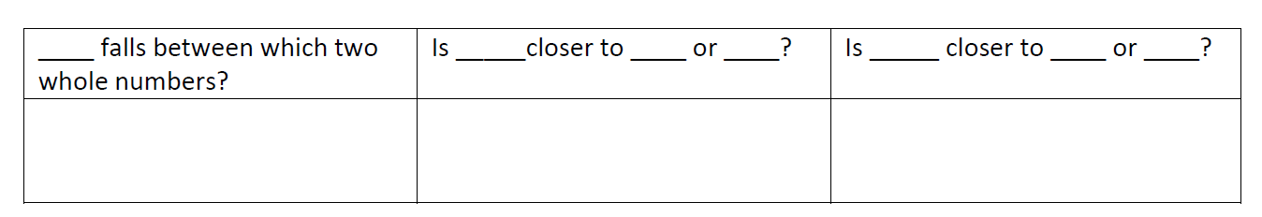
8.EE.1
Students often confuse the rules. This occurs primarily when students are taught to memorize the rules rather than understand what is happening in the properties by working with numerical expressions as in the suggestions above. It is important to present examples and let students discover what the rules are. Then students should be encouraged to write their reasoning so they can clarify the explanations for themselves.
8.EE.2
It is important for students to have multiple opportunities and exposures with perfect cubes. This is a new concept in the curriculum and many students struggle with finding cube roots. A common misconception for cube roots is that any number times 3 is a perfect cube. Building larger cubes from smaller ones gives students a visual that they can rely on.
8.EE.3
Students often confuse a very large number for a small number when written in scientific notation such as 4,000,000 for 4×10−6. This usually is a result of students trying to memorize a rule about moving a decimal point to the left or the right. Instead of teaching a rule, rely on students’ background knowledge of negative exponents. Before rewriting a number in standard form, look to the exponent to determine whether it is a small or large number. This can be used as a check.
Students who do not understand the properties of exponents also make errors in computation with scientific notation. Teachers may need to review these properties.
8.EE.4
When performing operations with numbers in scientific notation, such as (7×105)×(18×109), some students will be overwhelmed with keeping track of what they should do. Encourage these students to color code the numbers such as highlighting the numbers in exponential form in the given example so students remember to work them together.
8.EE. 5
Errors occur when students are overwhelmed by being presented with too much information at a time. Encourage students having difficulty making the comparisons to work with one relationship at a time. Graphing may be a difficult skill for some students. Use graph paper larger than 1 cm for these students so they can see the unit rate easier.
Students who are overwhelmed can also be helped by using graphs of experiences that are familiar to them. This makes the information more accessible so student can better understand and interpret proportional relationships.
8. EE. 6
A common error students make is to misuse the formula for finding the slope of a line given two points. They use x-y or use the difference of the x coordinates divided by the difference of the x coordinates divides by the difference of the y coordinates. Look for these common errors. Focus students’ attention on the errors by using error analysis task. For example, Jed used the following equation to find the slope of a line 𝑥1/𝑦1−𝑥2/𝑦2 .
Find Jed’s mistake and correct it.
8. EE. 7
A common error students make involves applying the distributive property when negative integers are involved, such as -2(-x-4). The error occurs when they try to multiply the -2 and the -4. Students need repeated exposure to equations of this type. Prompting students to consider “minus 4” as plus negative 4” helps correct the misconception. Providing and discussing task that involve students analyzing errors helps students self-correct many misconceptions.
8. EE. 8
Common errors for systems of equations include students who have accurately graphing and, therefore cannot correctly estimate the solution. Technology can be helpful as can graph paper with larger than 1-cm squares.

